ELEC-4200

Digital System Design

FROM: Jacob Howard

TO: Prof. Ujjwal Guin

DUE DATE: 3/4/21

Lab 7

# **Introduction**

The goal of this lab was to familiarize ourselves with various types of registers and various types of counters. A register stores bits of information in such a way that systems can write to or read out all the bits simultaneously. Most of the tasks were verified as functional by the TA.

# **Task 1**

In Task 1, we were asked to design a 4-bit register with synchronous reset and load. This code was provided for us so I won't show it in the report, but we still needed to develop a testbench and simulate the design. The simulation code can be found in *Testbench 1* and the simulation can be seen in *Figure 1* below.

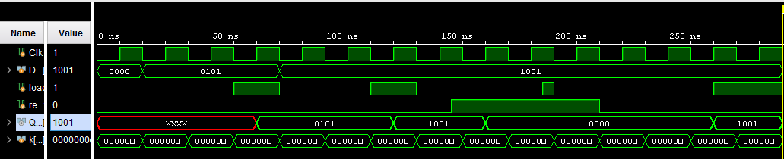

*Figure 1*

|  |
| --- |
| initial begin  #300 $finish; //runs simulation 100 times  end    initial begin  load = 0;  reset = 0;  D = 0;  #60 load = 1; //at 60ns  #20 load = 0; //80ns  #40 load = 1; //120 ns  #20 load = 0; //140 ns  #15 reset = 1; //122 ns  #40 load = 1; //195 ns  #5 load = 0; //215 ns  #20 reset = 0; //240 ns  #50 load = 1; //280ns  end    initial begin  D = 0;  #20 D = 4'b0101;  #60 D = 4'b1001;  end    //clock  initial begin  for (k = 0; k <= 100; k = k+1)  begin  Clk = 0;  #10 Clk = 1;  #10;  Clk = 0;  end    end  endmodule |

*Testbench 1*

# **Task 2**

In Task 2, we were asked to design Model a 4-bit register with synchronous reset, set, and load signals. No testbench was required for Task 2. Only physical testing was required. The code for this task can be seen below in *Code 2.*

|  |
| --- |
| always @(posedge Clk)  if (reset)  begin  Q <= 4'b0;  end  else if (set)  begin  Q <= 4'b1111;  end  else if (load)  begin  Q <= D;  end  endmodule |

*Code 2*

# **Task 3**

In Task 3, we were asked to design a 1-bit delay line shift register. We were asked to develop a testbench to simulate the design. Simulation can be seen below in *Figure 2*, code can be seen in *Code 3*, and testbench code can be seen in *Testbench 3* below.

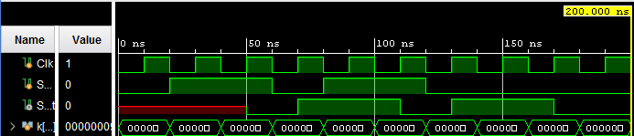

*Figure 2*

|  |
| --- |
| always @(posedge Clk)  shift_reg <= {shift_reg[1:0], ShiftIn};  assign ShiftOut = shift_reg[2];  endmodule |

*Code 3*

|  |
| --- |
| initial begin  #200 $finish; //runs simulation 100 times  end  //clock  initial begin  for (k = 0; k <= 1000; k = k+1)  begin  Clk = 0;  #10 Clk = 1;  #10;  Clk = 0;  end  end  initial begin  ShiftIn = 0;  #20 ShiftIn = 1;  #40 ShiftIn = 0;  #20 ShiftIn = 1;  #40 ShiftIn = 0;  end  endmodule |

*Testbench 3*

# **Task 4**

In Task, we were asked to model Model a 4-bit parallel in left shift register. We then were asked to create a testbench to simulate the design. The simulation can be seen in *Figure 3*, the code can be seen in *Code 4*, and the testbench can be seen in *Testbench 4* below.

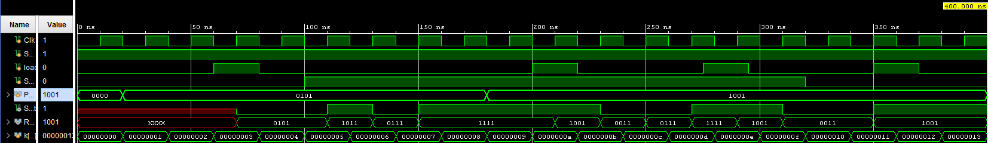

*Figure 7*

|  |
| --- |
| always @(posedge Clk)  if(load)  shift_reg <= ParallelIn;  else if (ShiftEn)  shift_reg <= {shift_reg[2:0], ShiftIn};  assign ShiftOut = shift_reg[3];  assign RegContent = shift_reg;  endmodule |

*Code 4*

|  |
| --- |
| initial begin  #400 $finish; //runs simulation 100 times  end  //clock  initial begin  for (k = 0; k <= 1000; k = k+1)  begin  Clk = 0;  #10 Clk = 1;  #10;  Clk = 0;  end  end  //load  initial begin  load = 0;  #60 load = 1;  #20 load = 0;  #120 load = 1;  #20 load = 0;  #55 load = 1;  #20 load = 0;  #55 load = 1;  #20 load = 0;  end  //ShiftEn and SHiftIn  initial begin  ShiftIn = 1;  ShiftEn = 0;  #100 ShiftEn = 1;  #220 ShiftEn = 0;  end  //ParallelIn  initial begin  ParallelIn = 0;  #20 ParallelIn = 4'b0101;  #160 ParallelIn = 4'b1001;  end  endmodule |

*Testbench 4*

# **Task 5**

In Task 5, we were asked to write a model for a 4-bit serial-in parallel-out shift register. We were also required to write a testbench for this. The code for this task can be seen in Code 5 below and the testbench can be seen in Testbench 5.

|  |
| --- |
| always @(posedge Clk)  if(ShiftEn)  shift_reg <= {shift_reg[2:0], ShiftIn};  assign ShiftOut = shift_reg[3];  assign ParallelOut = shift_reg;  endmodule |

*Code 5*

|  |
| --- |
| initial begin  #400 $finish; //runs simulation 100 times  end  //clock  initial begin  for (k = 0; k <= 1000; k = k+1)  begin  Clk = 0;  #10 Clk = 1;  #10;  Clk = 0;  end  end    initial begin  ShiftEn = 0;  #40 ShiftEn = 1;  #40 ShiftEn = 0;  #40 ShiftEn = 1;  #40 ShiftEn = 0;  #80 ShiftEn = 1;  #40 ShiftEn = 0;  #40 ShiftEn = 1;  #40 ShiftEn = 0;  end  initial begin  ShiftIn = 1;  #200 ShiftIn = 0;  end  endmodule |

*Testbench 5*

# **Task 6**

In task 6, we were asked to design an 8-bit counter using T flip-flops, extending the above structure to 8-bits. The code for this task can be seen in Code 6. We were also required to write a testbench which can be seen below in Testbench 6.

|  |
| --- |
| TFlipFlop U1 (.t(t), .enable(enable), .Clk(Clk), .clr(clr), .q(q1));  and (t2, t1, q1);  TFlipFlop U2 (.t(t2), .enable(enable), .Clk(Clk), .clr(clr), .q(q1));  and (t3, t2, q2);  TFlipFlop U3 (.t(t3), .enable(enable), .Clk(Clk), .clr(clr), .q(q3));  and (t4, t3, q3);  TFlipFlop U4 (.t(t2), .enable(enable), .Clk(Clk), .clr(clr), .q(q1));  endmodule |

*Code 6*

|  |
| --- |
| initial begin  #400 $finish; //runs simulation 100 times  end  //clock  initial begin  for (k = 0; k <= 1000; k = k+1)  begin  Clk = 0;  #5 Clk = 1;  #5;  Clk = 0;  end  end  initial begin  enable = 0;  #20 enable = 1;  #80 enable = 0;  #40 enable = 1;  end  initial begin  clr = 0;  #60  clr = 1;  end  endmodule |

*Testbench 6*

# **Task 7**

In task 7, we were asked to modify our code from task 6 so the 8-bit counter uses D flip-flops. Sadly I did not complete this part of the lab so I do not have any code to provide for this task.

# **Task 8**

In task 8, we were asked to model a 4-bit down-counter with synchronous load, enable, and clear as given in the code above. We were also required to write a testbench to simulate the design. This task was quite challenging and I never could complete the code for this task. Therefore, I do not have any code or design to provide for this task.

# **Conclusion**

In conclusion, this lab was very helpful for us to understand how to model different types of registers and counters. I did not feel like the lab as a whole was difficult, although I did run into some challenges. Some challenges I was able to solve with help of the Ta, while others, I could not figure out how to complete. Overall, this lab was not too bad, but the workload of having 8 steps can be difficult, especially when some tasks are quite harder than others.